

KINDLY SPONSORED BY

**CONCEPT TAVERNS / THE NORTHERN SNOOKER CENTRE**

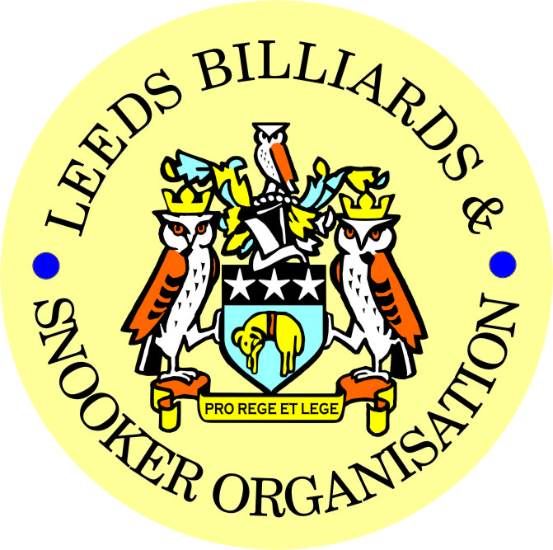  

|  |
| --- |
| ***FINAL – 2024/25 LEEDS CITY SNOOKER CHAMPIONSHIPS***  ***& PRIZE PRESENTATION EVENING***  ***WEDNESDAY 23rd JULY 2025***  ***NORTHERN SNOOKER CENTRE*** |

|  |
| --- |
| **2024/25 LEEDS CITY SNOOKER CHAMPIONSHIPS**  **SINGLES FINAL - BEST OF 7 FRAMES**  **DANIEL WOMERSLEY (4) v RICHARD BINNS (0)**  ***FOLLOWED BY-***   * **PRESENTATION OF THE SINGLES TROPHY & INDIVIDUAL AWARDS-** * **PRESENTATION OF ALL OTHER - 2024/25 LCC – Annual trophies and individual awards.** |

|  |  |
| --- | --- |
| **\*\* 2024/25 LEEDS CITY CHAMPIONSHIPS \*\*** | |
| **JUNIORS - UNDER 16’s SNOOKER:**  **Trophy - Presented by ADT Flexibles (UK) Ltd.** | |
| WINNER: **HARVEY HATTON** | RUNNER-UP: **JOHNNY COLLIER** |
|  | |
| **JUNIORS - UNDER 18’s SNOOKER:**  **“The Keith Weston Memorial Trophy”- Presented by ADT Flexibles (UK) Ltd.** | |
| WINNER: **DANIEL BOYES** | RUNNER-UP: **DILRAJ RYATT** |
|  | |
| **JUNIOR HIGH BREAK: - “The Paul Hunter Memorial Trophy” – DANIEL BOYES (77)** | |

|  |  |
| --- | --- |
| **INDIVIDUAL SNOOKER:** | |
| WINNER: **DANIEL WOMERSLEY** | RUNNER-UP: **RICHARD BINNS** |
| SEMI-FINAL: **MARK BALL** | SEMI-FINAL: **PETER RABY** |
| **PAIRS SNOOKER:**  **Trophy - Presented by ADT Flexibles (UK) Ltd.** | |
| WINNERS: **PETER LINES / DANIEL BOYES** | RUNNERS-UP: **J. BAGLEY / S. BROADHEAD** |
| SEMI-FINAL: **R. BINNS / G. CASSIDY** | SEMI-FINAL: **M. PRZYBYL / L. DICKINSON** |
| **TEAM SNOOKER – “The Jim Fowler’s Trophy”:** | |
| WINNERS: **NORTHERN S.C.** | RUNNERS-UP: **BELLE ISLE WMC** |

|  |
| --- |
| ***2024 / 2025 - *PRIZE PRESENTATION EVENING\****  ***WEDNESDAY 16th JULY 2025***  ***MIDDLETON CONSERVATIVE CLUB*** |

|  |  |
| --- | --- |
| **SNOOKER - “Veterans Trophy” – 50+**  **“The Rodney Sims Memorial Trophy”**  **Presented by the LBSO** | **REFEREES: -**  **Officiated in 2024-25 LBSO Competitions:** |
| **WINNER: HOWARD BRAZIL** | **GRAHAM MASON** |
| **RUNNER-UP: STEVE PARLOUR** | **JULIAN BELL** |
|  | **PAUL MARLOW** |
| **PLATE WINNER: RICHARD ASPIN** | **MARK BALL** |
| **PLATE RUNNER-UP: PETER HALL** | **BOB PATTERSON** |

|  |  |  |
| --- | --- | --- |
| **\*\* LBSO - SNOOKER LEAGUES \*\*** | | |
| **Div:** | **CUP TITLE / WINNERS:** | **RUNNERS-UP:** |
| **Div A** | **The Yorkshire Evening News Shield:**  **EAST END PARK WMC ‘B’** | **BELLE ISLE WMC ‘B’** |
| **Div B** | **The J. McDonnell / J. Williamson Trophy:**  **HAREHILLS LABOUR** | **TINSHILL & COOKRIDGE ‘A’** |
| **Div C** | **The John Dunning Trophy:**  **SOUTH LEEDS CONS ‘B’** | **SWILLINGTON MINERS WELFARE ‘A'** |
| **Div D** | **The Jerry Bird Memorial Trophy:**  **HORSFORTH CONS ‘A’** | **MIDDLETON CONS ‘B’** |
| **Div E** | **The Peter Nelson Trophy:**  **HORSFORTH CONS ‘B’** | **HUNSLET CARR SPORTS & SOCIAL CLUB** |
| **Div F** | **The Peter Hawkyard Memorial Trophy:**  **NORTHERN SNOOKER**  **CENTRE ‘D’** | **NEW MIDDLETON ‘B’** |

|  |  |
| --- | --- |
| **“CHAMPION of CHAMPIONS”**  **“The Jim Williamson Memorial Trophy”**  **Presented by the Northern Snooker Centre** | WINNERS: **SOUTH LEEDS CONS ‘B’**  **(DIVISION C WINNERS)** |

|  |  |  |
| --- | --- | --- |
| **LBSO - LEAGUE & COMPETITIONS – SNOOKER HIGHEST BREAKS -**  **HIGHEST BREAK TROPHY**  **Presented by ADT Flexibles (UK) Ltd. in 2019** | | |
| **Break** | **League / Competition** | **Player (Team)** |
| **133** | **LEEDS CITY CHAMPIONSHIP** | **DANIEL WOMERSLEY** |
| 118 / 103/ 100 | LEAGUE & COMPS | DANIEL BOYES |
| 113 | LEAGUE DIVISION B | LEE BROOKES |
| 97 / 87 | LEAGUE DIVISION D | CHRIS TOLSON |
| 93 | LEAGUE DIVISION A | GRAHAM MARSDEN |

|  |  |
| --- | --- |
| LEN LEE INVITATION SNOOKER – (Scratch):  **“THE LEN LEE TROPHY”**  **Trophy presented by**  **ADT Flexibles (UK) Ltd**  **for 2020** | WINNER: **DANIEL BOYES (GILDERSOME CONS)**  RUNNER-UP: **RICHARD BINNS (BELLE ISLE WMC)** |

|  |  |
| --- | --- |
| **SNOOKER – SYKES CUP - Individual Handicap.**  **The “GEORGE SYKES CUP”** | |
| WINNER: **DAVE FRENCH**  **(FARSLEY CONS)** | RUNNER-UP**: JOE CROSSTHWAITE**  **(BELLE ISLE WMC)** |
| SEMI-FINAL: **ADAM GREGORY**  **(NEW HEADINGLEY)** | SEMI FINAL: **PAUL NOLAN**  **(SWARCLIFFE WMC)** |

|  |  |
| --- | --- |
| **SNOOKER – LEN LEE PAIRS - Pairs Handicap.**  **The “LEN LEE CUP”** | |
| WINNERS: **E. ROBERTSON & G. SMITH**  **(BRAMLEY BAND)** | RUNNERS-UP: **A. RENNISON & A. HAWKHEAD**  **(HAREHILLS LABOUR)** |
| SEMI-FINAL- **J. BESIC & D. McCORMACK**  **(DENSISON HALL)** | SEMI-FINAL: **D. PARISH & J. LONGSTAFF**  **(BRAMLEY WMC)** |

|  |  |
| --- | --- |
| **SNOOKER - 3 MAN TEAM KNOCK OUT – Handicap.**  **The “3 Man Knock Out Trophy”** | |
| WINNERS: **GARFORTH WMC** | RUNNERS-UP- **MAIN LINE SOCIAL** |
| SEMI-FINAL: **MORLEY CONSERVATIVE CLUB** | SEMI FINAL:  **BELLE ISLE WMC** |

|  |  |
| --- | --- |
| **\*\* STAN BROOKE MEMORIAL COMPETITIONS \*\***  **(AGGREGATE SCORES – 3/4 FRAMES)** | |
| **INDIVIDUAL SNOOKER – 3 FRAMES:** | |
| WINNER: **MARK ASPIN**  **(MIDDLETON CONS)** | RUNNER-UP**: THOMAS OATES**  **(SOUTH LEEDS CONS)** |
| SEMI-FINAL: **JOHN REA**  **(EAST END PARK WMC)** | SEMI FINAL: **MATTHEW HOLGATE**  **(ROTHWELL WMC)** |
| **PAIRS SNOOKER – 3 FRAMES:** | |
| WINNERS: **J. HUDSON & O. HUDSON**  **(CROSSGATES REC HALL)** | RUNNERS-UP:  **T. BARKER & L. MORLEY**  **(DENISON HALL)** |
| SEMI-FINAL: **R. POPPLE & G. POPPLE**  **(UPPER & LOWER WORTLY LIBS )** | SEMI-FINAL: **A. McNICHOL / P. REILLY**  **(NEW HEADINGLEY)** |
| **TEAM SNOOKER – 4 FRAMES:** | |
| WINNERS: **BELLE ISLE WMC** | RUNNERS-UP: **NORTHERN SNOOKER CENTRE** |
| SEMI-FINAL: **BRAMLEY WMC** | SEMI-FINAL: **SOUTH LEEDS CONS** |

|  |  |
| --- | --- |
| **The “WINDSOR TROPHY” – 4 Man Team Handicap**  **Presented by ADT Flexibles (UK) Ltd.** | |
| WINNERS: **BELLES ISLE WMC** | RUNNERS-UP:  **MIDDLETON CONS** |
| SEMI-FINAL: **MAIN LINE SOCIAL** | SEMI FINAL: **HUNSELET CARR S & S** |

***CONGRATULATIONS!***

***TO ALL PRIZE WINNERS FOR 2024-25***

**The LBSO would like to thank-:**

* **Middleton Conservative Club for staging tonight’s presentation for the 2024/25 season.**

**and also**

* **Concept Taverns / the Northern Snooker Centre for staging the final of the 2024/25 Leeds City Snooker Singles Championship / Presentation of all 2024/25 Leeds City Champions, which will be held on Wednesday 23rd July 2025 at the NSC.**

|  |
| --- |
| Presented By-  C:\Users\user\Pictures\Miscellaneous\LBSO Logo.jpg  ***CURRENT LBSO COMMITTEE MEMBERS***  *PRESIDENT – CHRIS WILLIAMSON*  *CHAIRMAN – ANDY TAFFINDER*  *VICE CHAIRMAN –*  *LEAGUE SECRETARY – PAUL GRIMES*  *COMPETITION SECRETARIES – MARK BALL & PAUL MARLOW*  *GENERAL SECRETARY / TREASURER – BOB PATTERSON* |

**Kindly Sponsored by the**

**CONCEPT TAVERNS / ‘NORTHERN SNOOKER CENTRE’**

  